**Measurements and Instrumentation Lab (Aug-Dec 2022)**

**Lab Mini Project Report**

**Date of submission: 26/10/2022**

.

1. **Title of project: Vibration Analyzer**
2. **Team:**

|  |  |  |  |  |
| --- | --- | --- | --- | --- |
| **Registration No** | **Batch** | **Roll no** | **Name** | **Signature** |
| 200906413 | A2 | 62 | BRADLEY CHRISBEN BANGERA |  |
| 200906416 | A2 | 63 | DHAIRYA MAHESH CHAUHAN |  |
| 200906318 | A2 | 49 | PARTH GUPTA |  |

1. **Objective:**

To design and develop a system to monitor the level and patterns of vibrations within a component or structure of a machine and detect abnormal vibration events to determine the machine’s overall condition.

1. **Design Solution:**
2. **Working Principle:**

The sensor is mounted on the machine with the sensor mount.The sensor

The LabView acquires data from the ADXL345 sensor via the Arduino using the I2C protocol and then displays the data on the LabVIEW front panel .

When the vibrations of the sensor crosses a user defined limit then the relays are turned OFF, a indicator LED is switched ON to indicate that a fault has occurred and the program is stopped

1. **Circuit Diagram:**

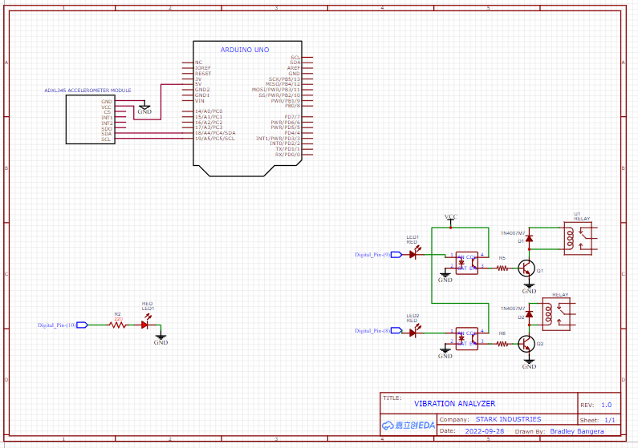

Figure 1:Circuit Diagram

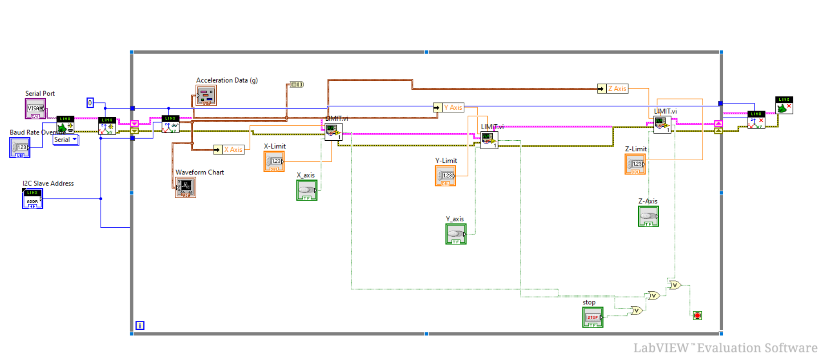

Figure 2:VI-Block Diagram

1. **Flowchart:**

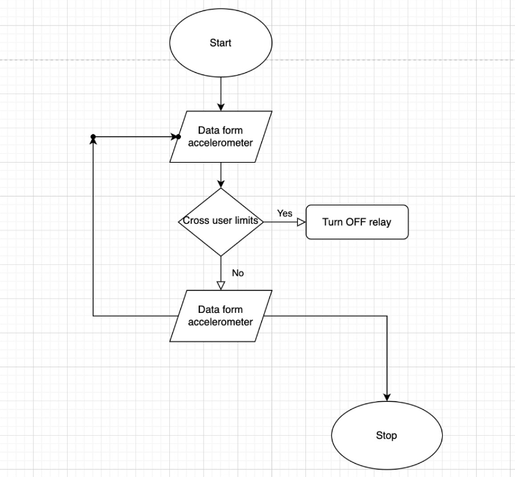

Figure 3:Flowchart for the VI

1. **Results/Simulations:**

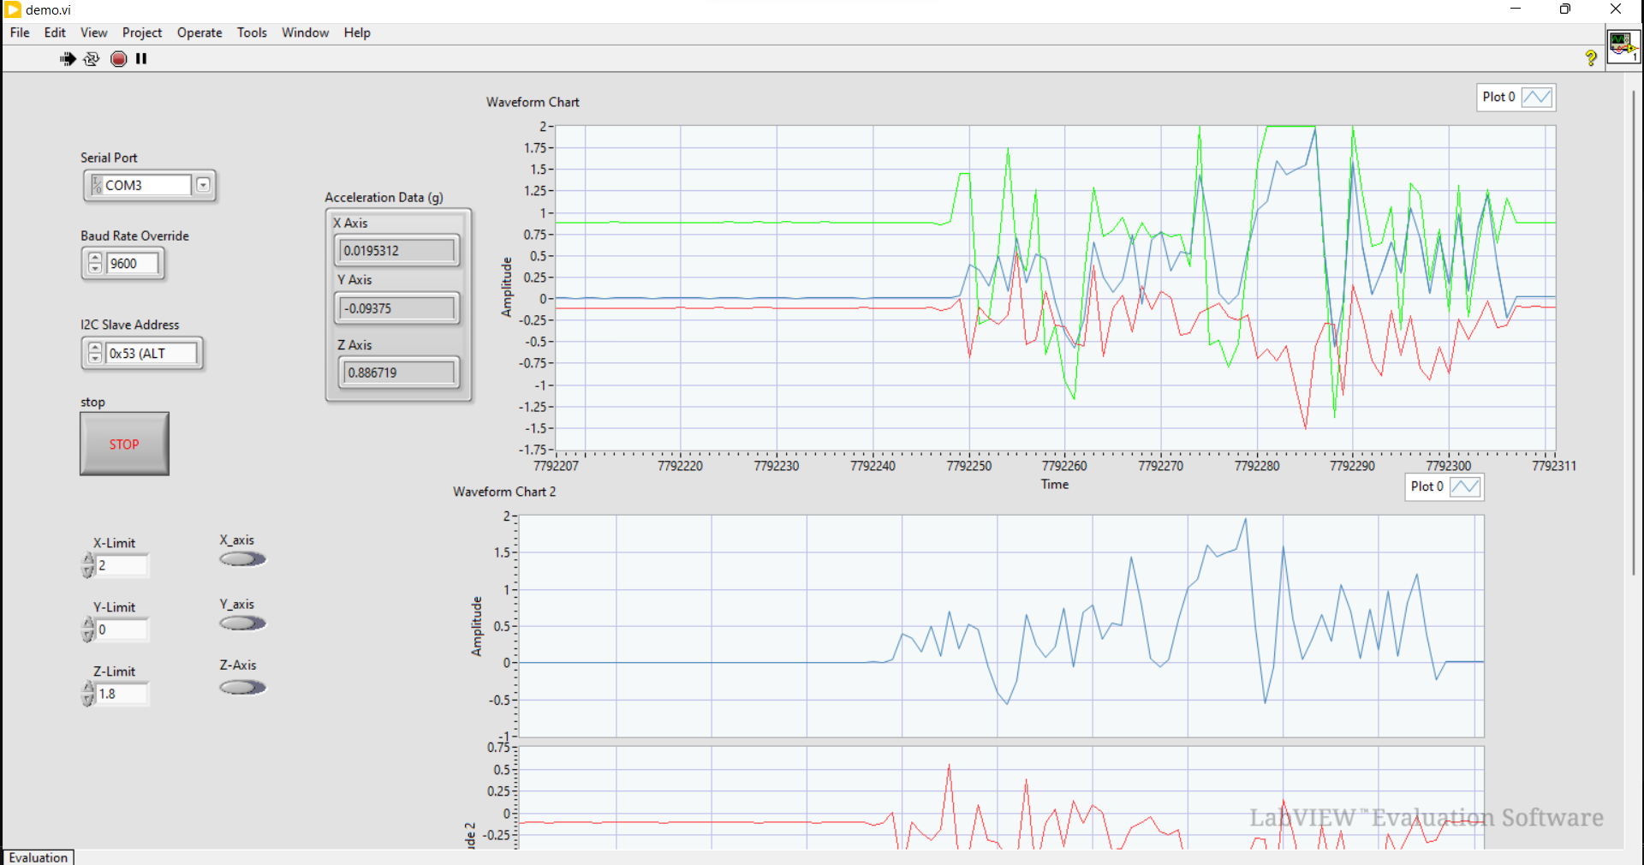

Figure 4:Front Panel VI

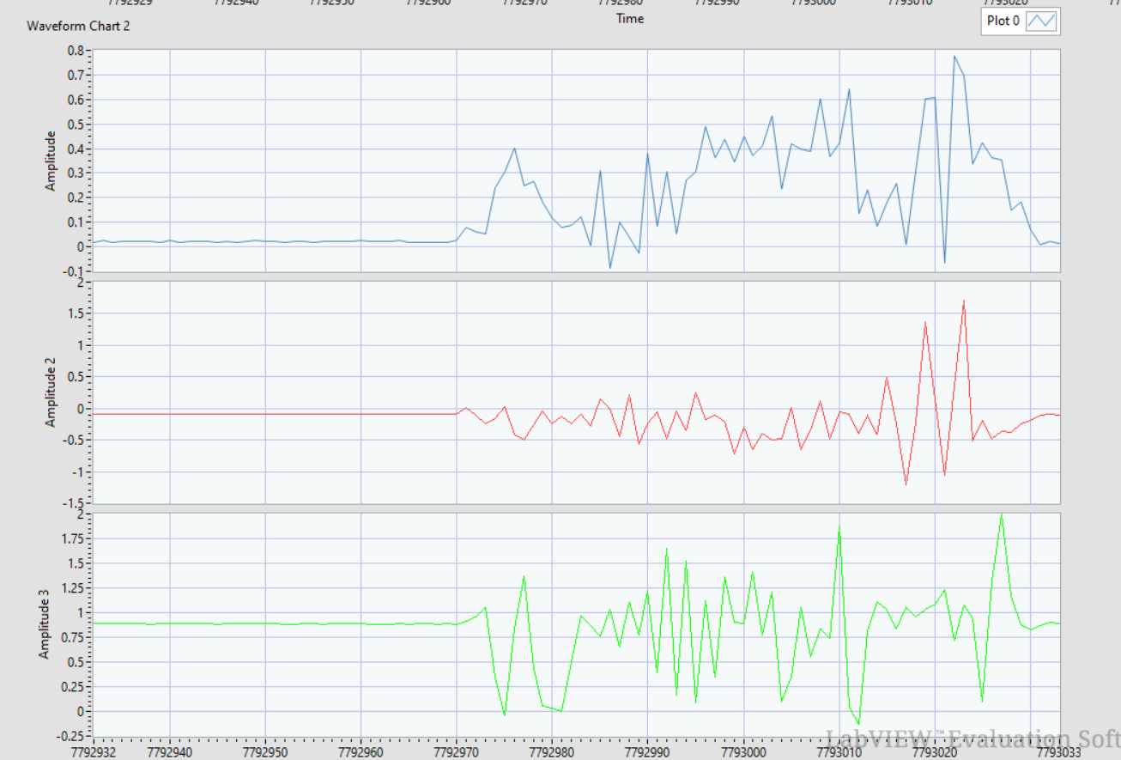

Figure 5:Front Panel Graph For each Axis

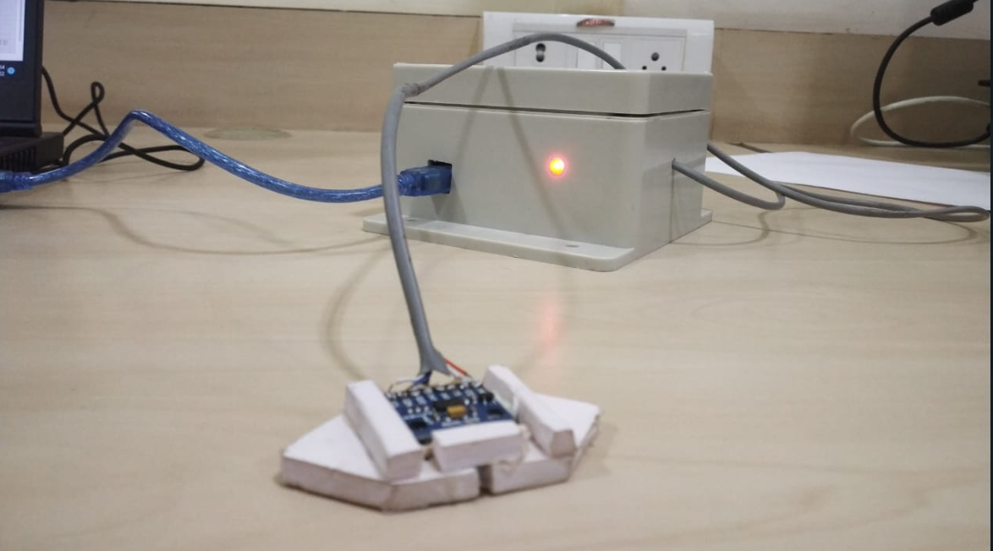

Figure 6:Hardware Setup

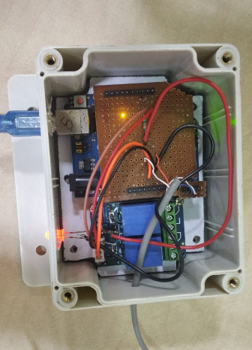

Figure 7:Hardware Within Enclousure

1. **Conclusion:**

* The project met the required objectives.The sensor was capable of detecting the vibrations and the VI was able to identify the fault(sudden Rise in Amplitude of Vibrations) and Trigger the Relay OFF.
* The device has met the objective which was to analyze vibrations of a machine and shut off the fault to prevent further damage
* The setup is capable of plotting and displaying all the data on the front panel as shown in the diagram

1. **Limitations Of The Project:**
2. **Accelerometer Range**: Our current accelerometer has a very low frequency detection range and thus cant be used for real life applications.
3. **Design of the Sensor Mount:** we are looking into different methods of mounting the accelerometer onto the machine. The current solutions in the market use threaded metal studs or Permanent magnets to mount the sensor. The use of threaded studs ensures a proper fit of the sensor on the machine frame but requires a measuring point on the frame to do so, whereas the use of magnets allows us to place the sensor at any point of a metal frame of the machine.
4. **Frequency analysis** : the VI has to be programmed to calculate the frequency components of the vibrations
5. **Impact on public safety and/or cultural societal or environmental:**
6. Machines produce vibrations under normal operation. These vibrations produced by machinery are vital indicators of machine health. Vibration analysis is used as a tool to determine a machine’s condition and the specific cause and location of problems, minimizing downtime and repair costs.
7. Untimely machinery breakdown due to faults such as imbalance, wear misalignment, etc causes significant losses, especially to the manufacturing company, as it can result in high monetary losses both from a potential motor or parts replacement, energy spikes within the system, and equipment downtime causing a halt in production.
8. **Thoughts on team work:**

**Parth** – It was an amazing experience to work with my peers to find a real-life application of the theory we learn in class and then building a practical hardware design solution.

**Bradley**-Doing our part and coming together to assemble the whole project was an insightful experience. Working together as partners to help each other for a common goal strengthened the interpersonal skills, team work and coordination of the individual members of the team.

**Dhairya**-building the project was a insightful experience and was rewarding in terms of knowledge and hardware experience.

1. **Bill of Materials:**

|  |  |  |  |  |
| --- | --- | --- | --- | --- |
| **Sl No** | **Component list** | **Cost per unit (Rs)** | **Quantity** | **Total (Rs)** |
| 1 | Arduino Nano | 300 | 1 | 300 |
| 2 | ADXL345 3-Axis  Accelerometer and  Gyroscope Module (I2C) | 325 | 1 | 325 |
| 3 | Miscellaneous: Perf  Board,Connectors, Enclosures,Screws, etc | - | - | 350 |

1. **CAD Models:**

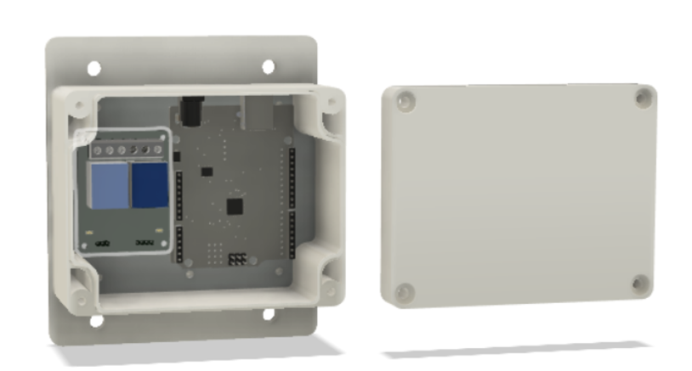

Figure 8:CAD Model

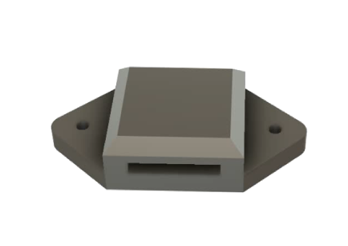

Figure 9:Sensor Mount CAD